Minimal Pairs are a easy starter activity for students to practice listening and distinguishing between two sounds that sound the same. A common example is the r and l.

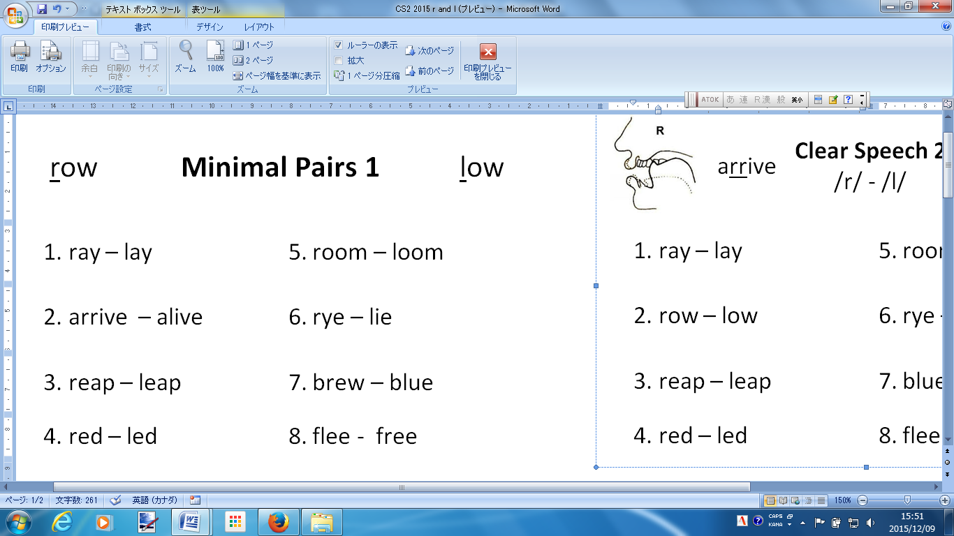

I would write the two examples on the board row and low. Have students repeat the words and have the JTE give tips on how to make the sound.

Next I would tell students to take out a pen or pencil and circle the word that they hear.

I would read the one word.

Example.

Number one. Ray, Ray, There is a ray of light.

Number two. Alive, alive, The boy is alive.

After reading all the words we would cover the answers.

Students would answer by saying left or right.